

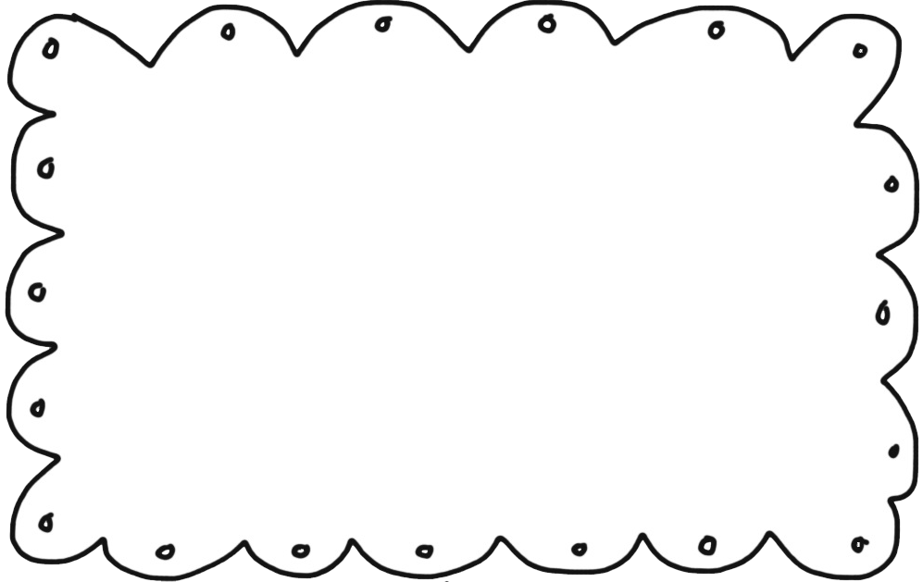
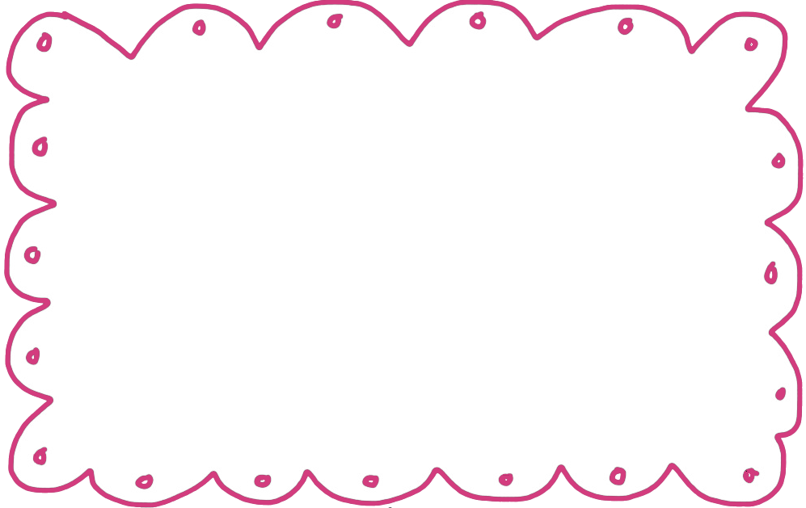
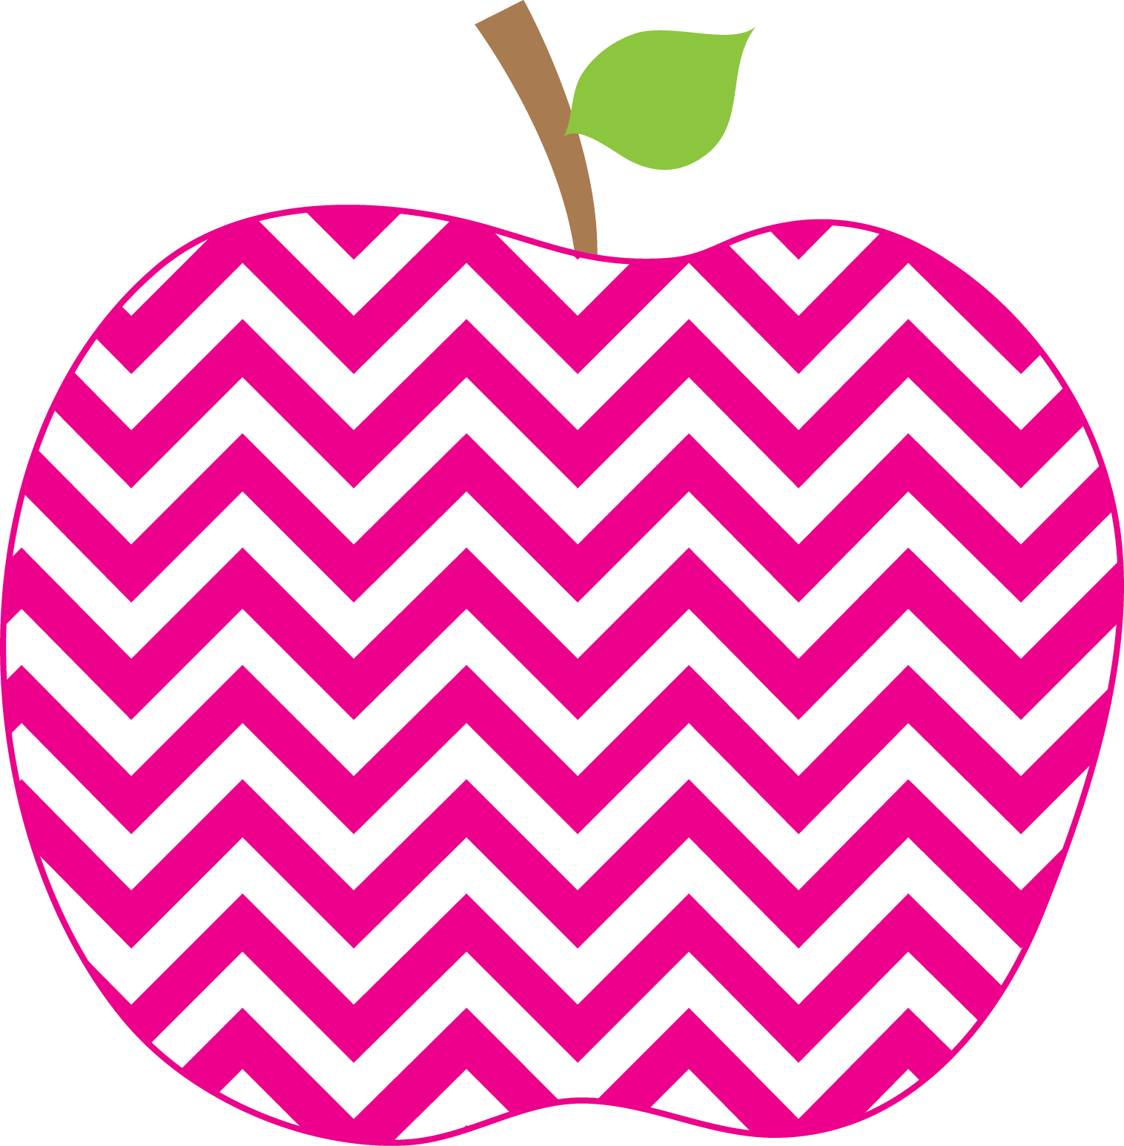

Weekly News

MRS. HOLLOWAY’S CLASS Nov 13th SSept.12t19Sep16th

Literacy-
This week I am going to be reading some Fancy Nancy Books and will create our Fancy Nancy Word Wall, I am encouraging the children to recognize “fancy” words in read alouds, and to use them in their writing.

The sight words for the week are: two, than, no, me, look

Reviewing the name of, sound of and formation of Z K.

We will continue with the Bossy R controlled vowels from last week and will introduce the short oo sound as in look, and the long oo sound as in moo.

The word family will be the “ook” family

The Reading Strategy for the week will be Flip the Dolphin and relating this to the two sounds for oo.

Writing-. Conventions… capital letters, spacing, punctuation and using correct spelling and phonemic spelling approximations will be stressed. We will also begin noticing quotation marks in stories and begin to add them to writing pieces.

Math-
The students are doing well with both 2D and 3D shapes and are working on sorting them by attributes.
We will continue with this outcome as well as daily work on number sense, especially the numbers in the teens.

We have the SPCA coming in to do a presentation so please send in donations if able. Also gift cards for the Home and School Basket would be appreciated. They have extended the deadline.

Learning Focus for the Week
For the next few weeks our You and Your World focus will be on Diversity and Respect. I have several wonderful books that we will be reading, and some great songs and videos. We have a very culturally diverse classroom and school and it is amazing how the children respect and enjoy learning about different cultures.

The students did an amazing job Thursday leading the PEACE assembly with the poem, Peace Begins with Me, and for singing two fabulous songs about Peace. Mrs. Coulombe made a video of both classes describing what Peace means to them, and she has put it on the school website. Be sure to check it out!
Homework
Books have been put in the red reading folders for the week. Please read and re read for greater comprehension and fluency. At home have your children look around the house to find both 2D and 3 D shapes and tell you about them.
Information

